Check which Ubuntu images you can use for creating a VM...

The following will command will generate a list of Azure VM images

You can pipe to a regular expression to pull out just the stable (LTS) Ubuntu images of a certain version (14.04.1).

It's also possible to add a --json property to get back data in JSON format.

**azure vm image list | grep 'Ubuntu.*14_04_1.*LTS''**

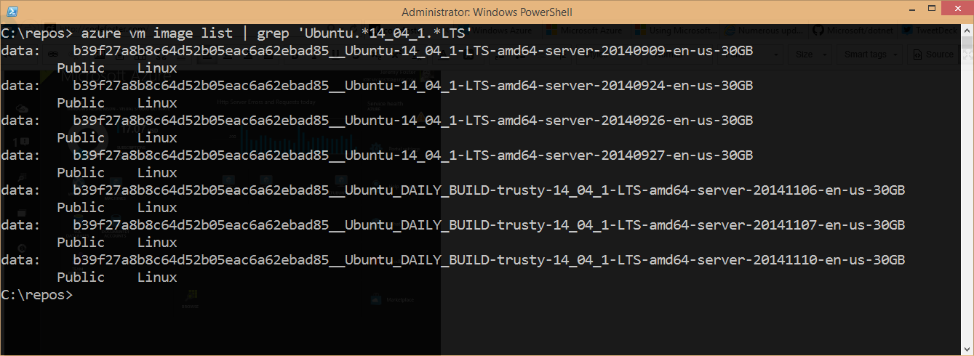

Create an Ubuntu Linux VM from one of those images...

Once you chose the image you want to start with,

you call the following to create a new VM

this will create a VM in the West US region.

I add the -e parameter to add ssh capability so I can ssh into the machine when it's finished.

azure vm create -l 'West US' VM_NAME b39f27a8b8c64d52b05eac6a62ebad85__Ubuntu_DAILY_BUILD-trusty-14_04_1-LTS-amd64-server-20141110-en-us-30GB codefoster -e

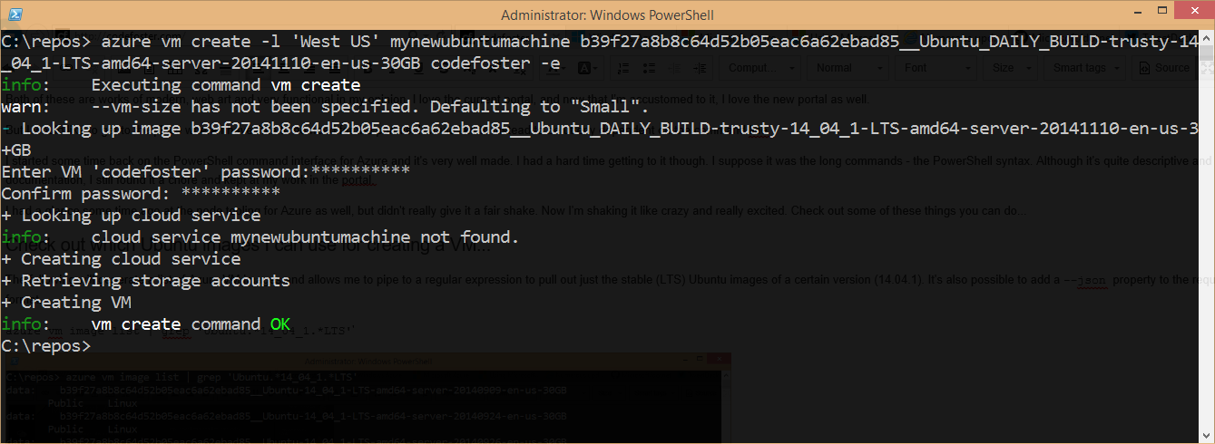

Now let's fetch a list of my VM's and see the new mynewubuntumachine

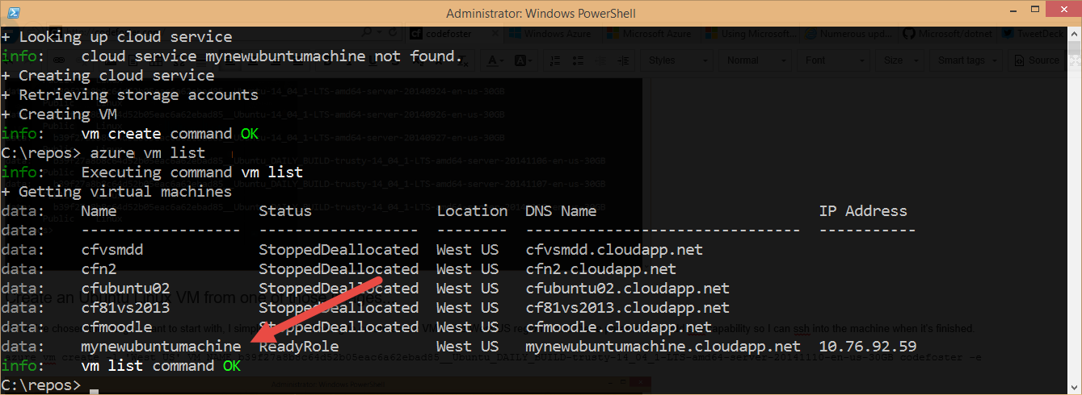

Now to set the machine not start charging you for compute,

shut it down and it will cost nothing (except for a little bit of storage... pennies)...

